**MINI PROJECT**

**(2020-2021)**

**ANDROID APPLICATION BASED ON**

**WOMEN SECURITY.**

**MINI PROJECT REPORT**



**Institute of Engineering & Technology**

**Submitted by-**

Shailam(181500646)

**Supervised By*: -*** Mr. Vinay Aggarwal (Technical Trainer)

# **Department of Computer Engineering & Applications**

**Contents**

**1.Introduction**

1.1General Introduction to topic

1.2Hardware Requirements

1.3Software Requirement

**2.Problem Statement**

**3.Objectives**

**4. Implementation Details**

**5.Screenshots**

**6.Certificate**

**Abstract**

In our Country, even though it has super power and an economic development, but still there are many crimes against women. Security for women has become a major issue as the number of crimes over women and girls increasing day-by-day. This paper describes about women safety and their security by using electronic device to both detect the problem & alert Authorities.This paper suggests a new perspective to use technology to protect women.We use an android based smart phone with an integrated feature that alert and provide location based Information. This Document describe GPS and GSM based **“Women Security System “**that provides the combination of GPS devices as- well-as provide alerts and message with an emergency button Trigger. Whenever somebody is in Trouble They Only have to press Volume Key Button After that a message alert is sent to Register Contact list and a Voice Call to the Number registered first and give a message **“I AM In TROUBLE PLEASE HELP ME”** Now a day safety of women is becoming very poor with the help of this Application The project was development in Android Which Graphical User Interface it provide the level of reliability, availability and compatibility .All these make Android an appropriate language for this project because Android language is based on JAVA language.

**Keywords: Women security, Smartphone, Registered contacts, Database, GPS (Global Positioning System), GSM (Global System For Mobile).**

**INTRODUCTION**

Women are accomplished at mobilizing diverse groups for frequent causes. They often work across racial, sacred, opinionated, and intellectual divides to encourage tranquillity.

We are aware of importance of women's security, but we must recognize that they should be well secured. A Woman is not much powerful when compared to men physically, in a crisis situation and needs a helping hand to relieve them. The best way to minimize chances in becoming a victim of violent crime (robbery, sexual assault, rape, domestic violence) is to identify and call on resources to help you out of unsafe situations. Whether you are in instant trouble or got separated from friends during night and do not know how to get home, having these apps on your phone can diminish your risk and bring assistance when you require it.

In the light of recent outrage in Delhi which shook the nation and woke us to the safety issues for our daughters, public are gearing upbeat in different ways to fight back. A swarm of new apps have been developed to provide security systems to women on their phones.

**PURPOSE:-**

The main purpose the project is to provide highly reliable security system for the safety of women. The proposed system is based advanced sensors, Microcontroller and GSM. The basic aim of the system is to develop a low cost solution for GPS based women tracking system (women safety system). The main objective of the system is to track the current location of the person which has an android enabled mobile by extracting the longitude and latitude of that target person.

**Proposed System:-**

The proposed system is especially for the women safety and overcomes the disadvantages of existing system:-

This proposed system is ‘GSM & GPS Based women Security System’. It consists of GPS device ie. any Android Phone and an emergency button. GPS device must to be placed inside the device (Android Phone). The device will provide the position information such as latitude, longitude of women. An emergency button is fixed on the device at a particular position. Whenever women in any kind of trouble she will press the emergency button and an alert will be immediately sent to the nearest police station. Then it is the responsibility of police squad to handle the situation.

**Features:-**

1) This project presents an alert system for Women safety detection.

2) The system provides a realizable and efficient.

3) The application is easier to use all the woman.

4) The application is normal budget.

5) For user there is no need of external hardware or software to use this application

6) This application is free for user, which does not affect user’s cost

7) User only need a Smartphone or tablet which has Android OS to the work.

**System Modules:-**

This project contains the following four modules:

***\*Profile Module***

Profile is an important component to users, which helps the users to add his/her personal details: Name, Address, Email Id, Mobile Number.

***\*Police Station***

The user will get information about the nearer police station.

***\*Emergency Contacts***

Required details of one who is in danger will be contacted to the right persons or family members or friends or help lines

***\*Emergency Button***

When we sense any danger, we can escape by using emergency button.

**Hardware Requirements:-**

* Android Operating System
* Min 2GB RAM (Memory)

**Software Requirements:-**

* Desktop or Smartphone
* Android Studio
* Internet Connection

**Block Diagram:-**

Block diagram of project show two users one is victim (Women) and another one is relatives. Victim user long press volume key then first find location (Longitude and Latitude) and send Message with lon-gitude and latitude to relatives. Report will be generate all the message details and relatives who receive message.

**Functional Description:**

A user should be able to:

* Add emergency contact numbers.
* View and Change the emergency contact number after adding.
* Add their message for emergency help.
* Find nearest police station and contact number.

**Data Flow Diagram (DFD):-**

Data Flow Diagrams are a graphical tool used to describe and analyze the movement of data through a system. DFD’s are used to capture the essential feature of both existing real system and future physical implementation of the system. The DFD is a graphical technique that depicts the information flow and the transforms that are applies as data move from input to the output.

* **Level-0 DFD Shows outline of the System Models**



* **Level-1 DFD**:-

This shows the separation of all external modules, relationship between those modules and the application.



* **-2 DFD:-**

This differentiates the modules frontend and backend.

* **Level-2 DFD**

This differentiates the modules frontend and backend



**Objective**

Our objective is to create an app

1. Which is user friendly.

2. Can help a user in multiple ways.

3. Have no ads.

4. No paid features everything is free.

5. Open source so no trouble for security.

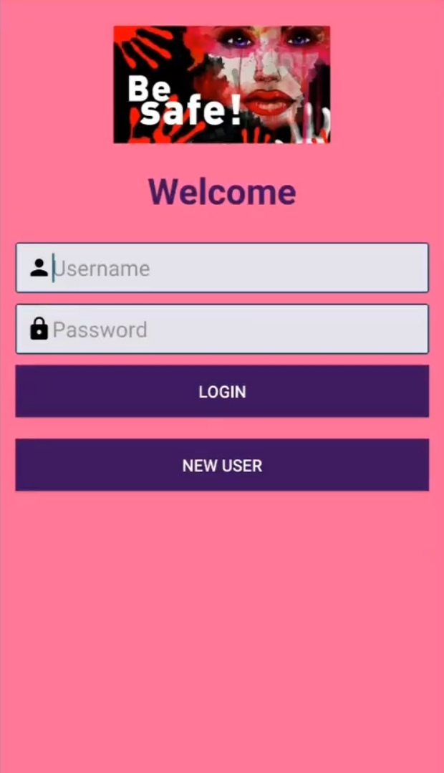

Username: In this user enter own username.

Password: In this user enter password.

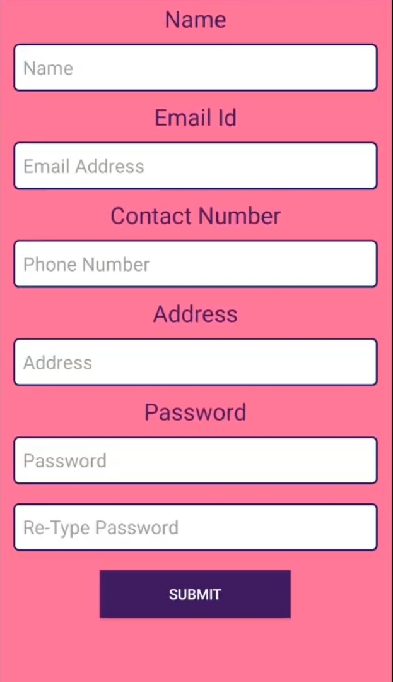

User Personal Information.

Name: Username

Email id , phone number, Address.

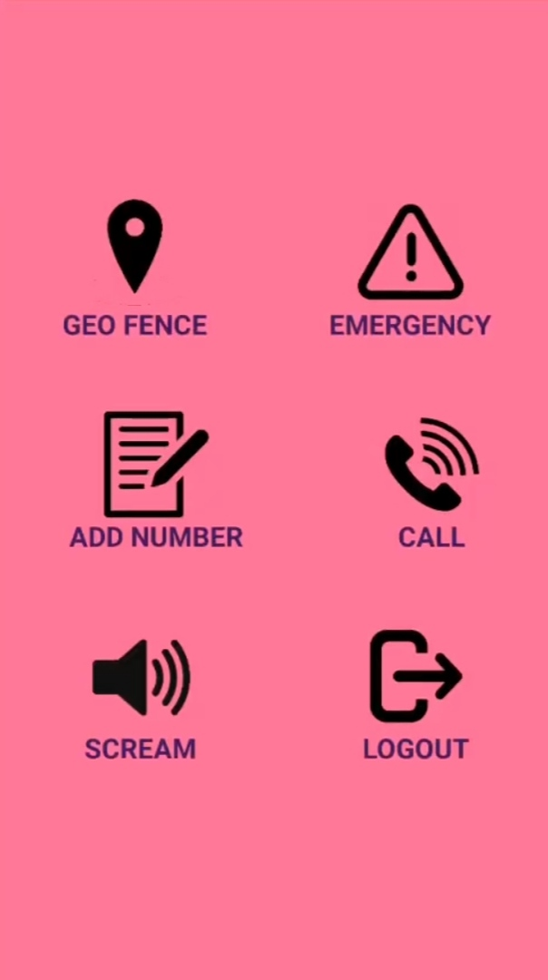

**Inner interface of application**

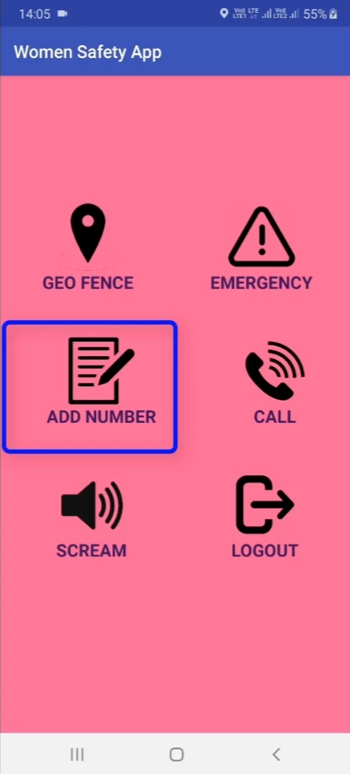

**Adding Numbers of relatives and Emergency numbers**.

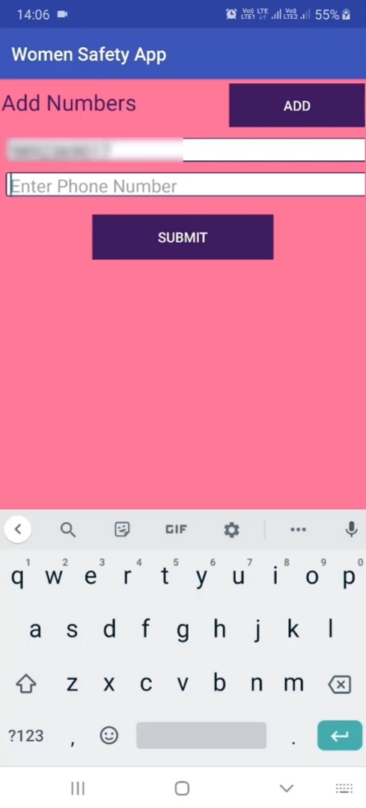

**Add numbers : Those numbers you will want send help message and calls.**

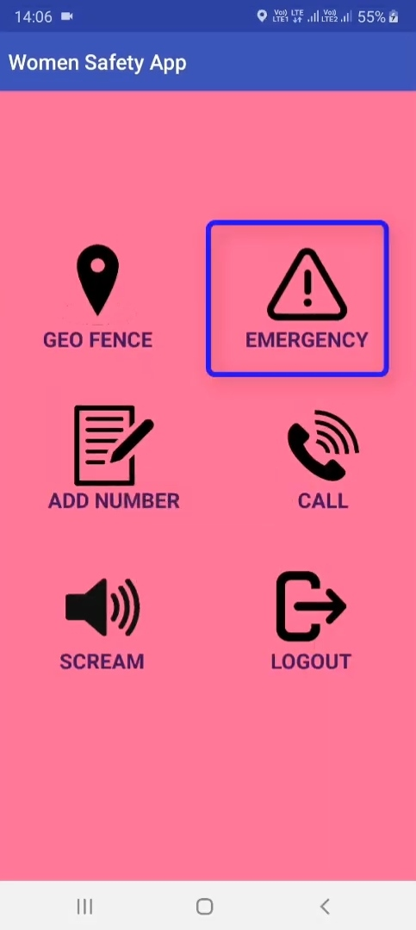

**Emergency: An emergency SMS will be sent to add numbers with users current location.**

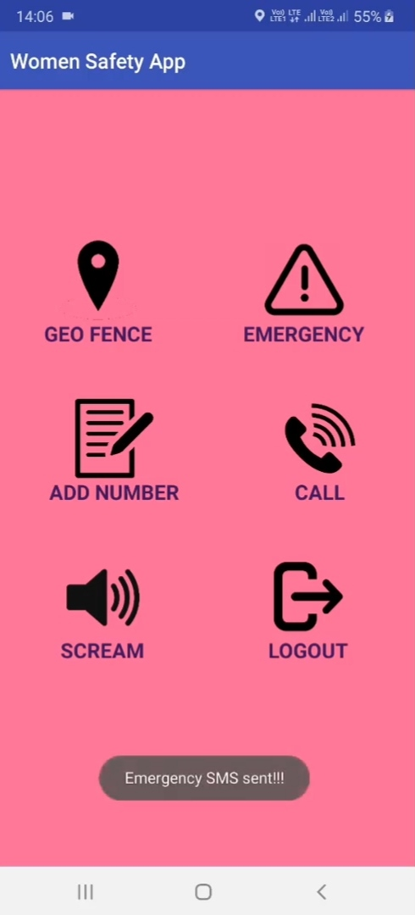

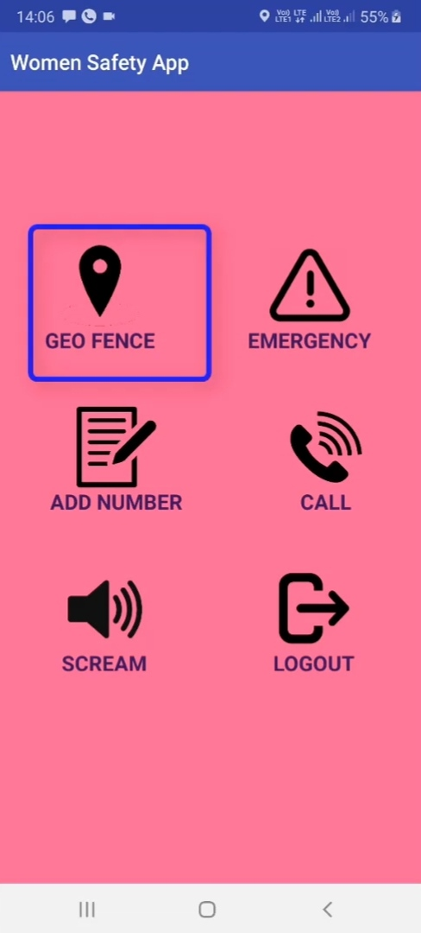

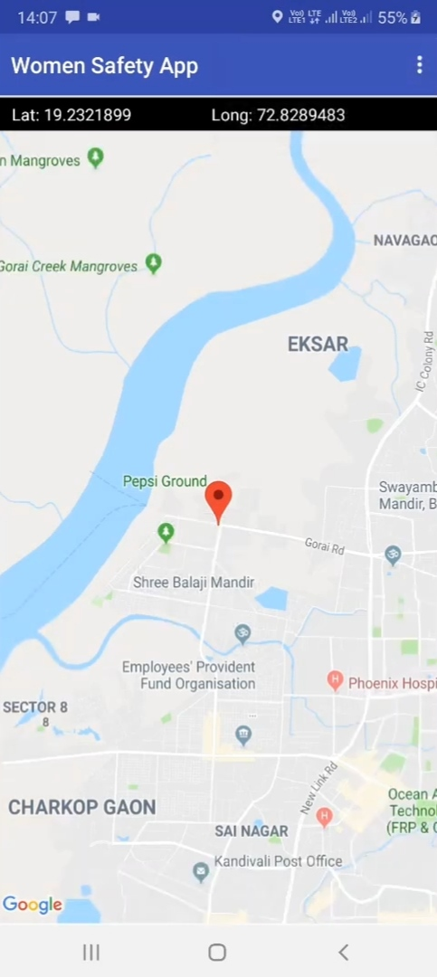

**This is current location of user with latitude and longitude.**

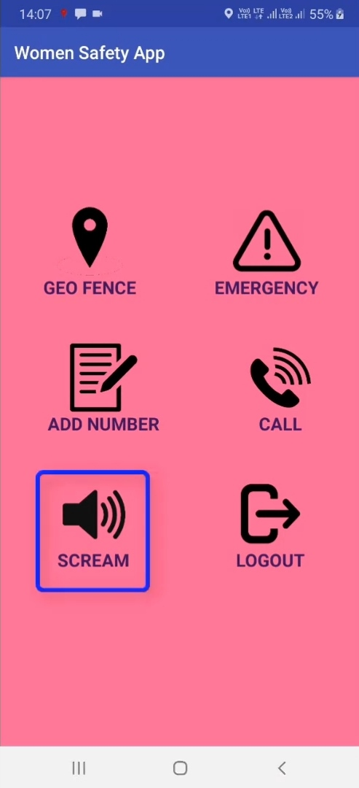

**Scream: This will play an emergency alarm.**

**Alarm will continues to play unless the app is removed from current running apps.**

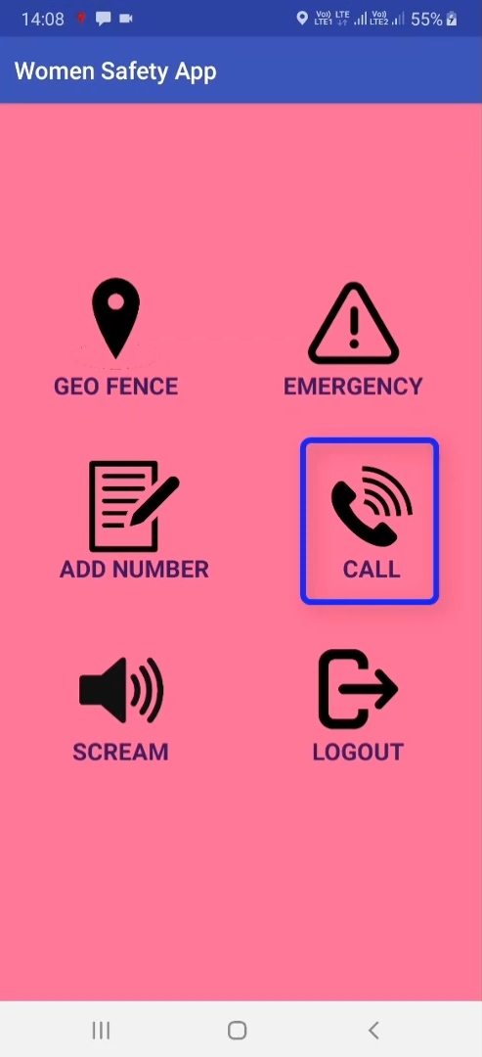

**Call: For call in emergency.**

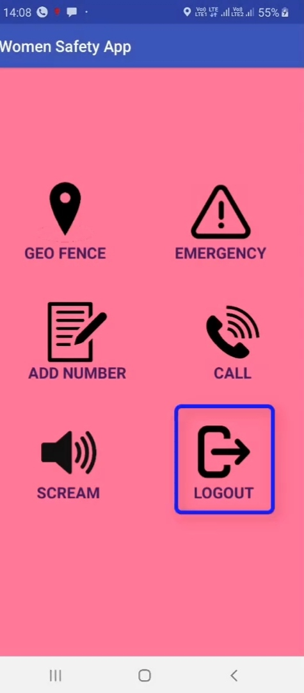

**Log Out: User log out her login id. If she edit personal information**

**TIPS FOR SAFE**

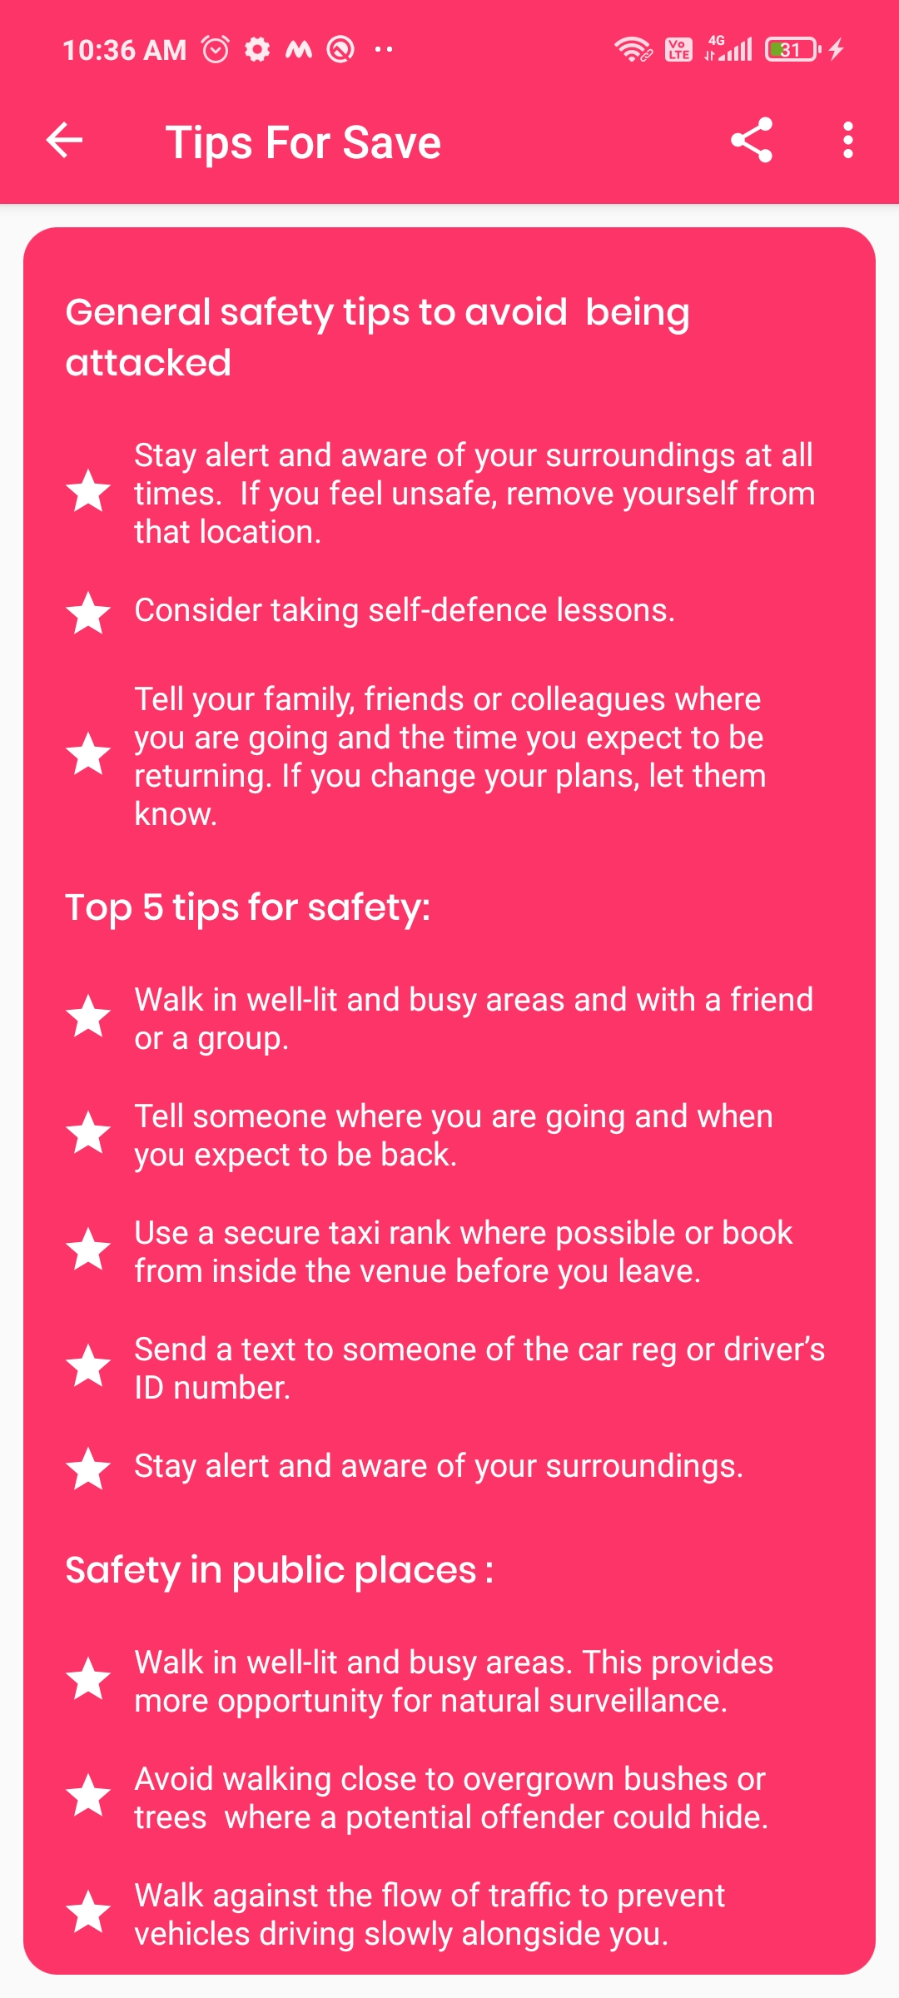

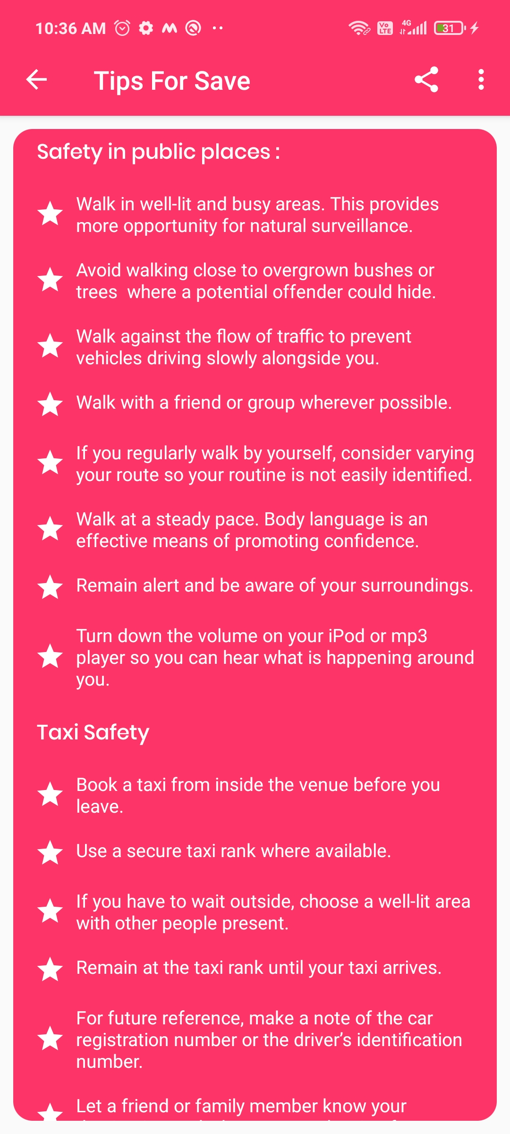

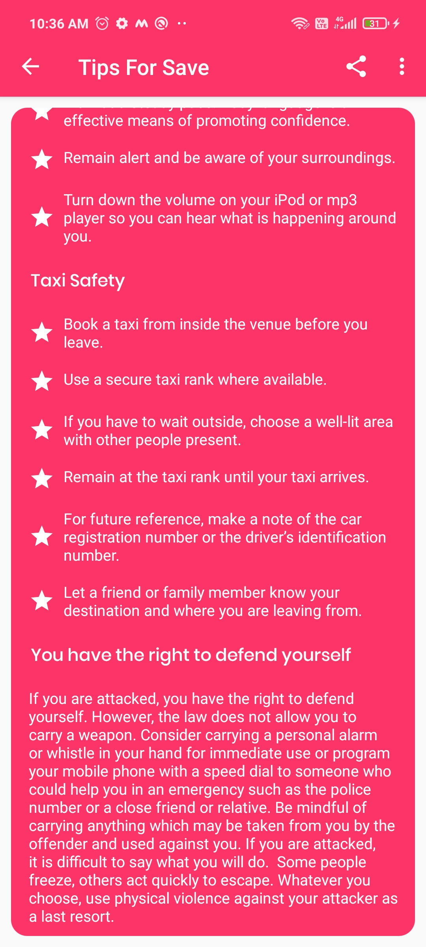

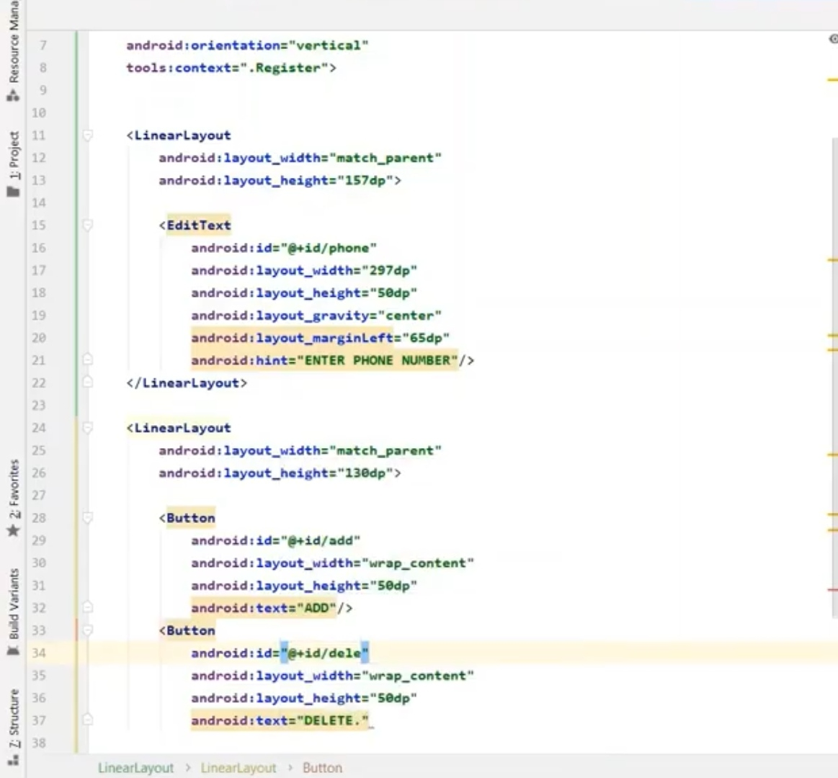

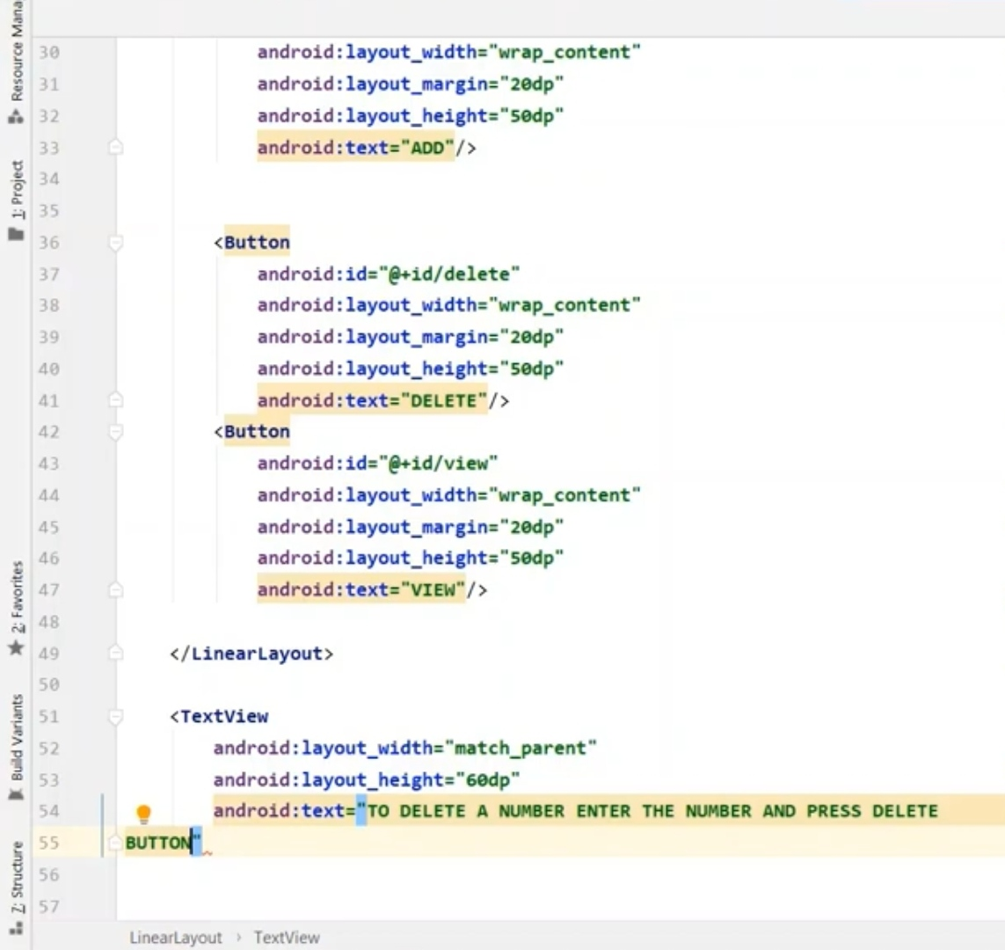

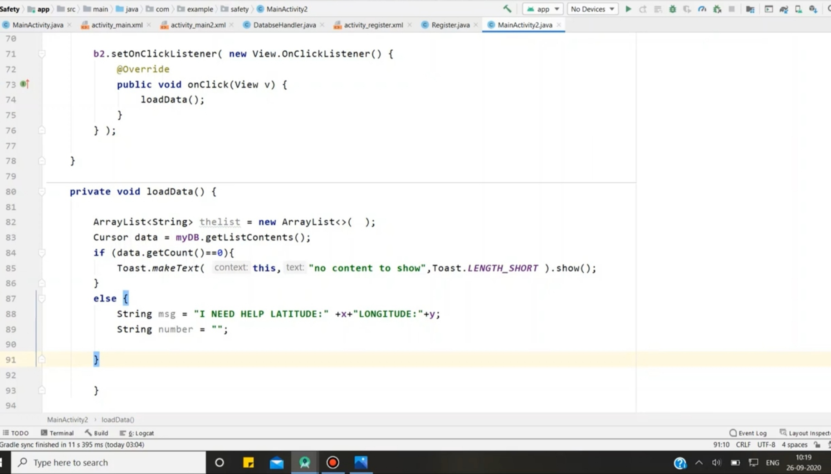

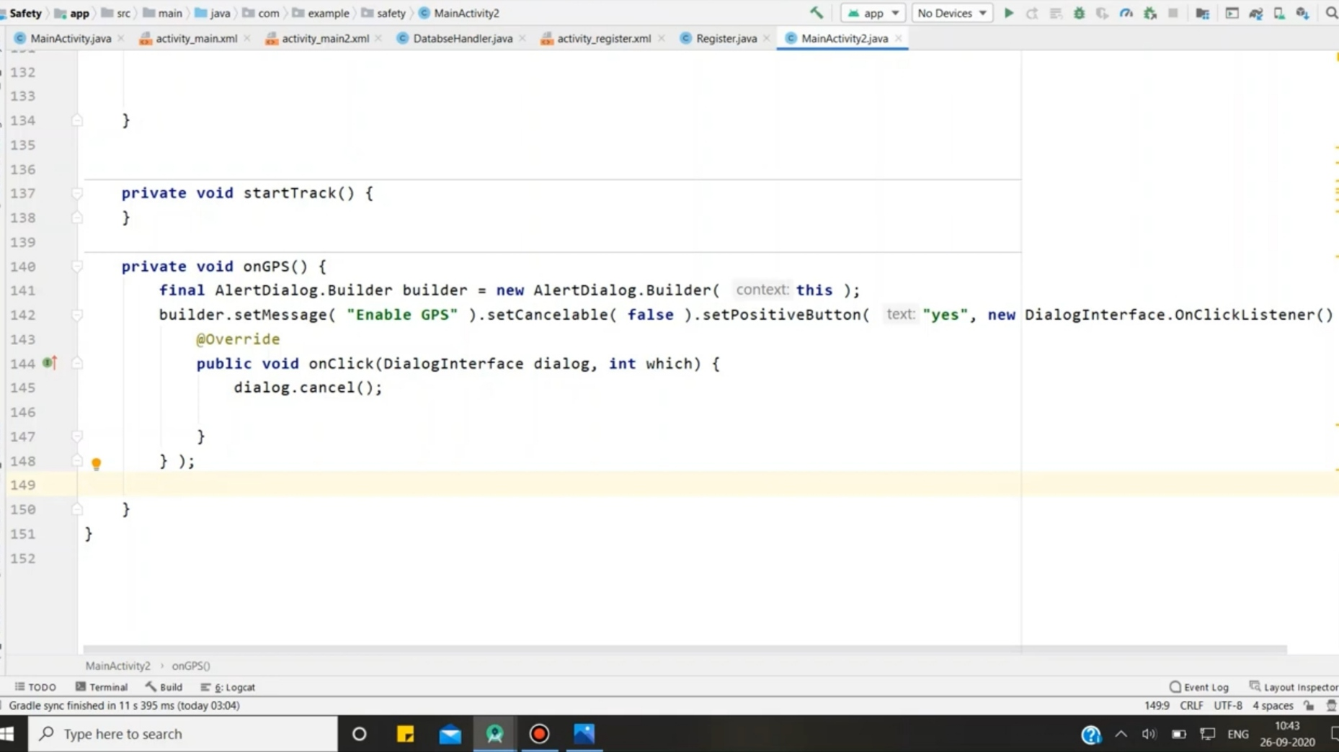

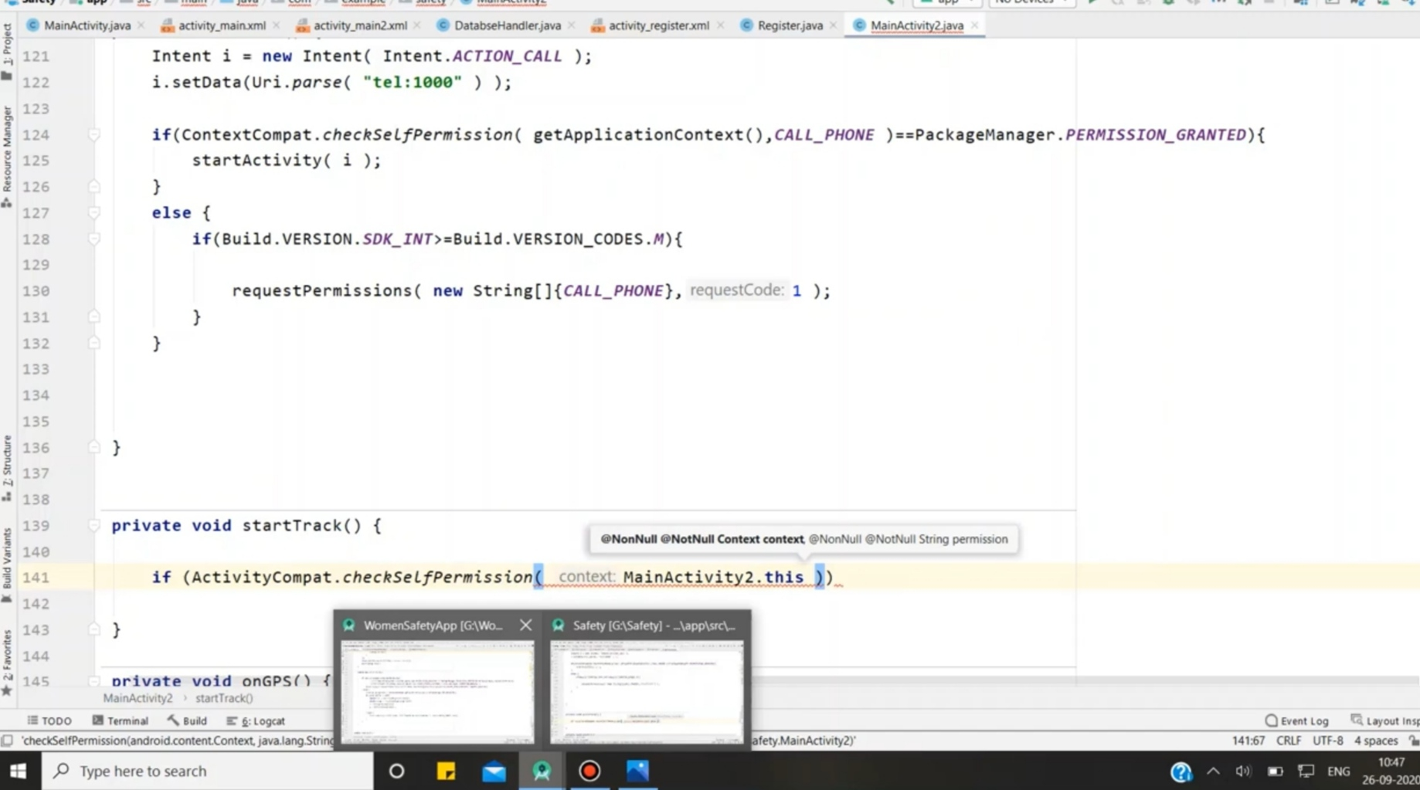

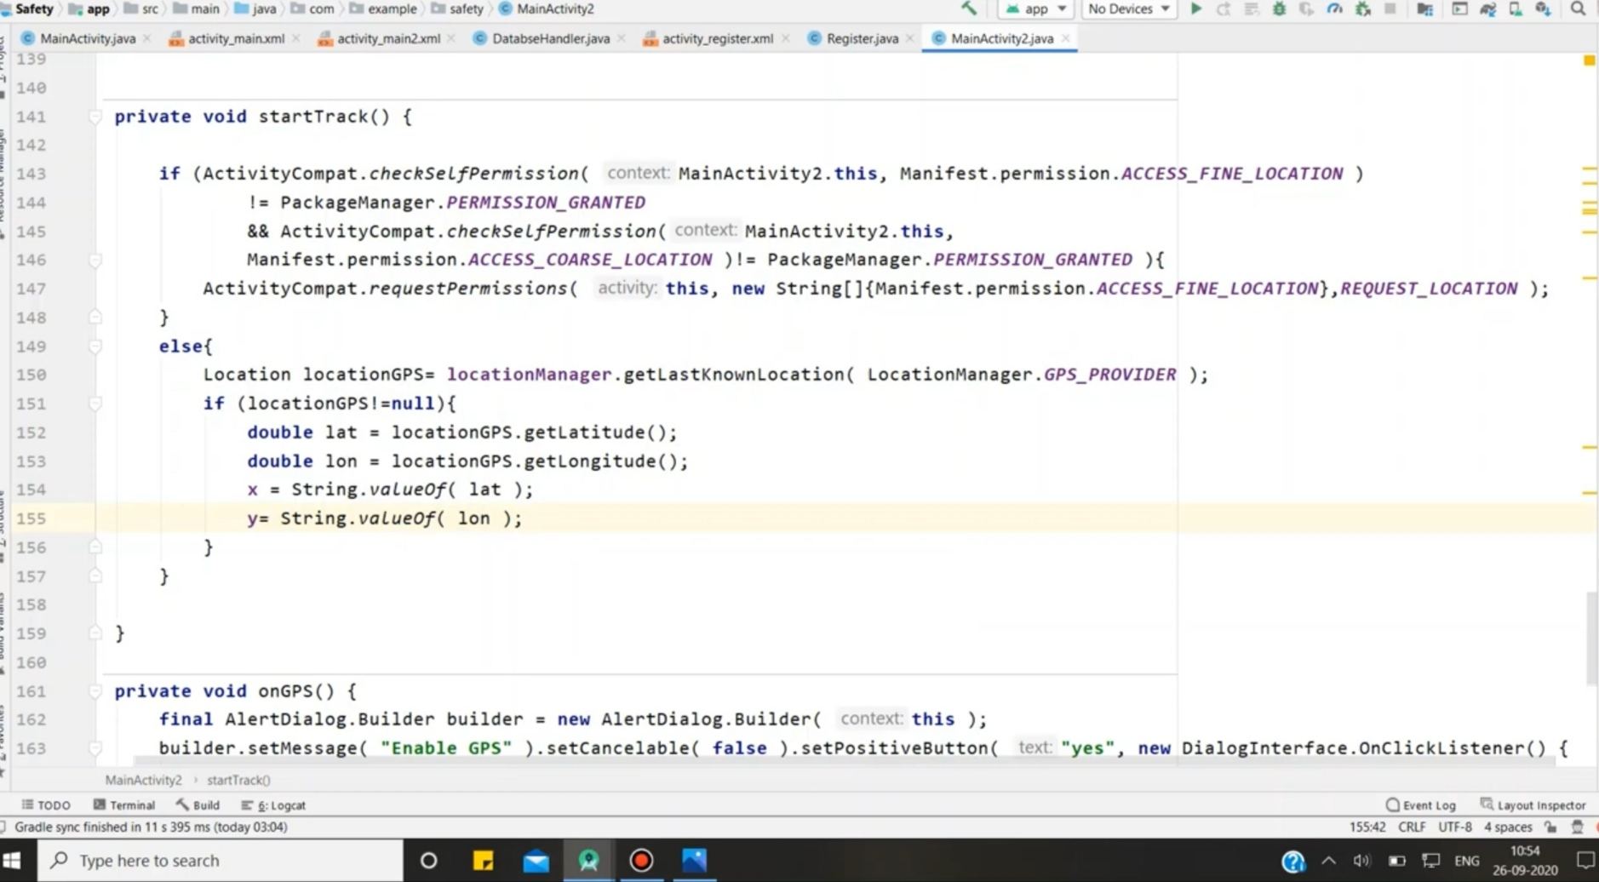

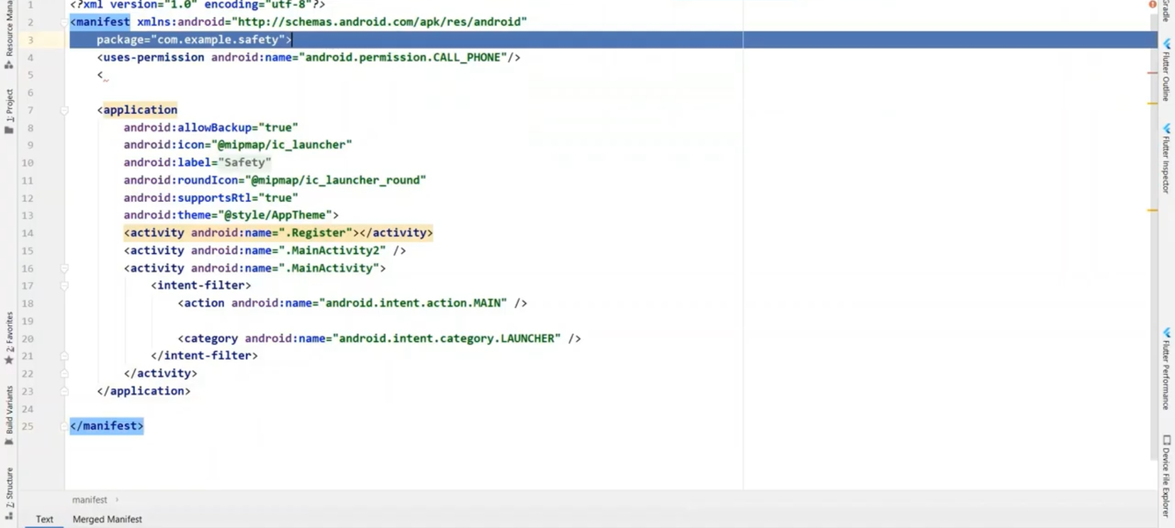

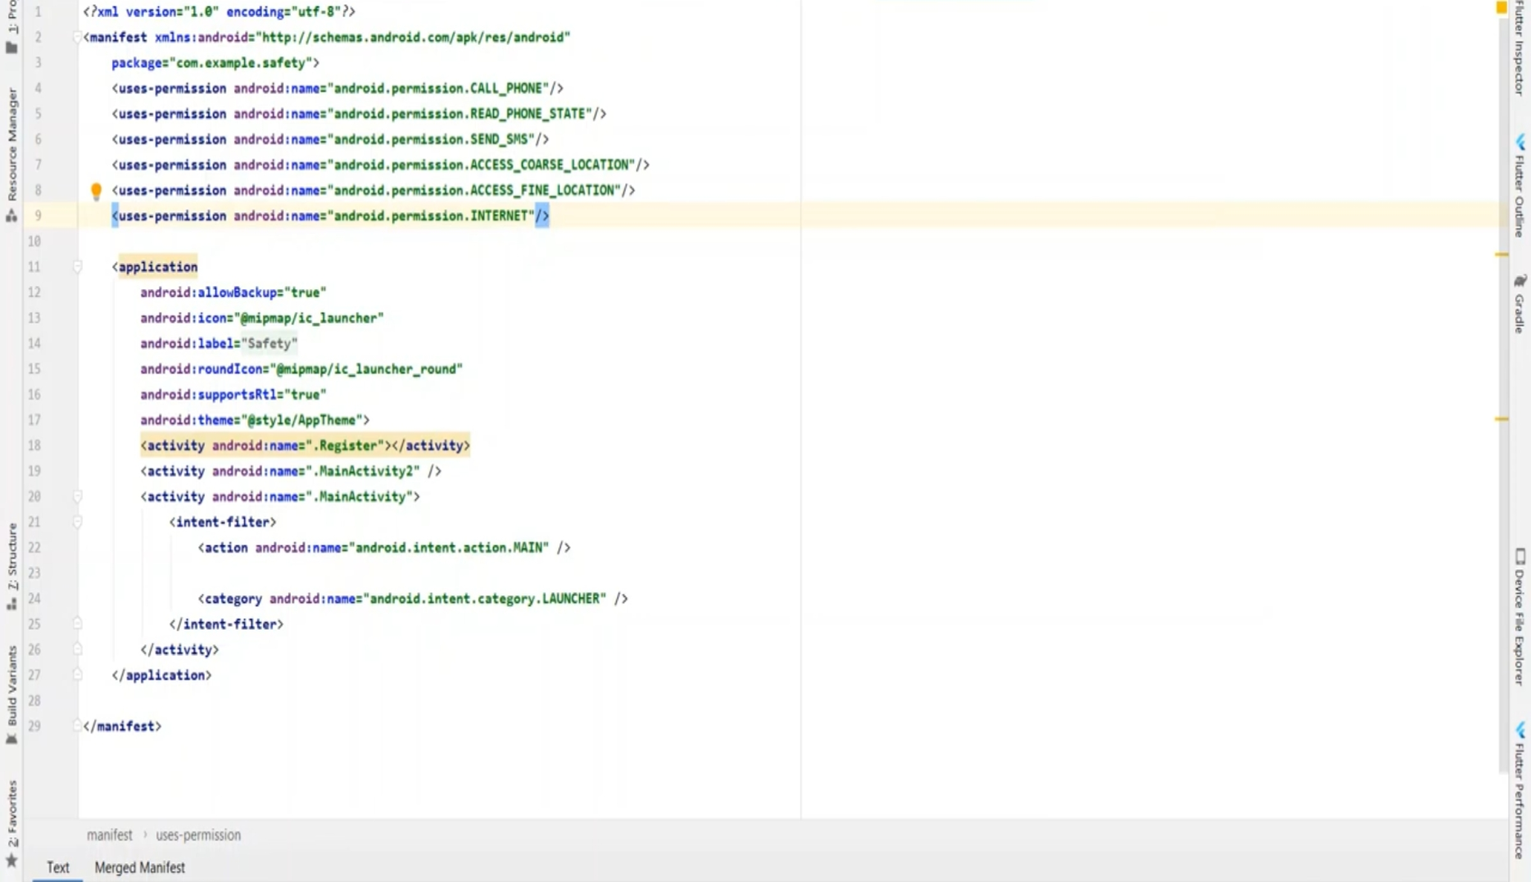



By pressing volume key, Women security app will only make call to the first number registered but it will send the emergency message to all the contacts added in the emergency contact list. If both the internet and location of victims android phone will turned on then GPS will fetch the location automatically and send an emergency message to all contacts with the exact location of victim and their landmark with longitude and latitude in two messages. So that the nearby associate can reach the victim easily for His/Her help.

**CONCLUSION**

The problem of the women safety is increased rapidly in this environment, so I proposed as an effective Android application to prevent such type of the suspicious or natural disaster, by alerting the concern authorities using the android mobile phone which helps to stop such type of illegal activates and to trace the concern.

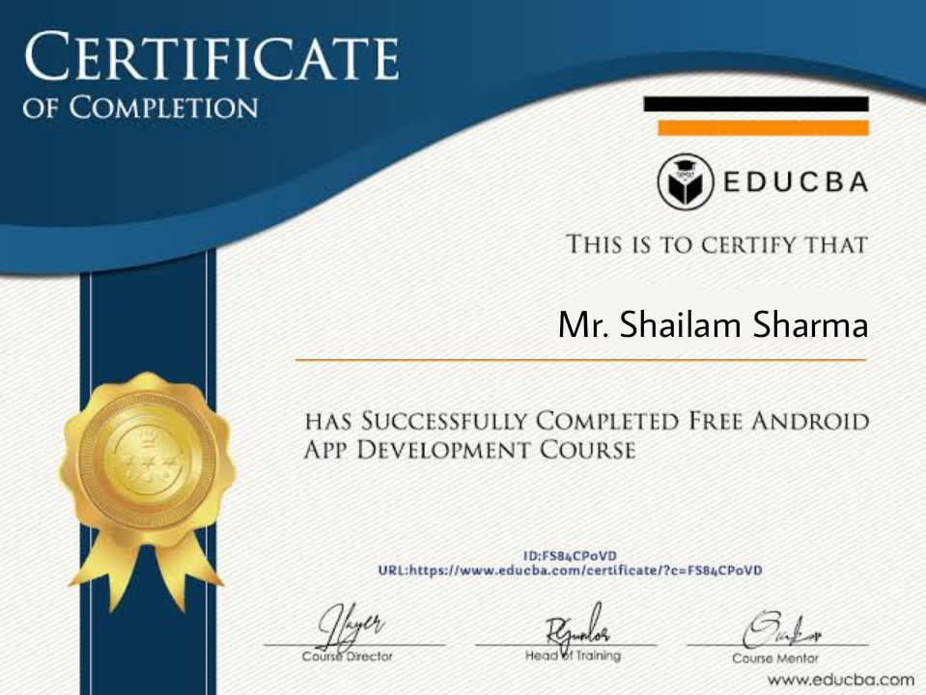

**References**

• https://wwwyoutube.com/ code with harry - code with harry youtube page helped me alot in learning how to use android studio

*Android Programming Tutorials by Mark L. Murphy

*http://en.wikipedia.org/wiki/android

* https://play.google.com/store/apps/details?id=com

**\*Mentor Mr. Vinay Aggarwal Sir**